**Two basic computer architectures:**

[**Von Neumann Architecture:**](https://www.geeksforgeeks.org/computer-organization-von-neumann-architecture/)   
Von Neumann Architecture is a digital computer architecture whose design is based on the concept of stored program computers where program data and instruction data are stored in the same memory. This architecture was designed by the famous mathematician and physicist John Von Neumann in 1945.

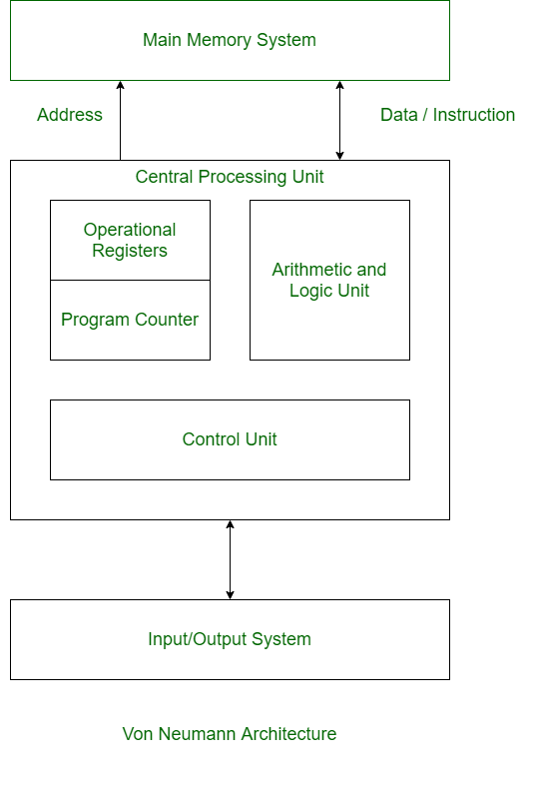

[**Harvard Architecture:**](https://www.geeksforgeeks.org/harvard-architecture/)   
Harvard Architecture is the digital computer architecture whose design is based on the concept where there are separate storage and separate buses (signal path) for instruction and data. It was basically developed to overcome the bottleneck of Von Neumann Architecture.

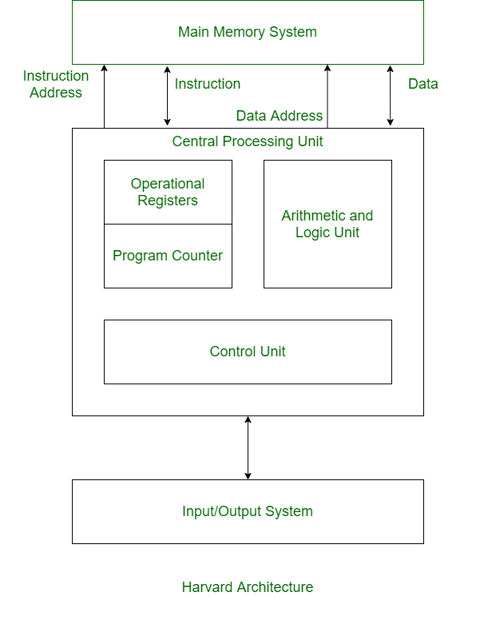

**Difference between Von Neumann and Harvard Architecture:**

| **VON NEUMANN ARCHITECTURE** | **HARVARD ARCHITECTURE** |
| --- | --- |
| It is ancient computer architecture based on stored program computer concept. | It is modern computer architecture based on Harvard Mark I relay based model. |
| Same physical memory address is used for instructions and data. | Separate physical memory address is used for instructions and data. |
| There is common bus for data and instruction transfer. | Separate buses are used for transferring data and instruction. |
| Two clock cycles are required to execute single instruction. | An instruction is executed in a single cycle. |
| It is cheaper in cost. | It is costly than Von Neumann Architecture. |
| CPU can’t access instructions and read/write at the same time. | CPU can access instructions and read/write at the same time. |
| It is used in personal computers and small computers. | It is used in micro controllers and signal processing. |